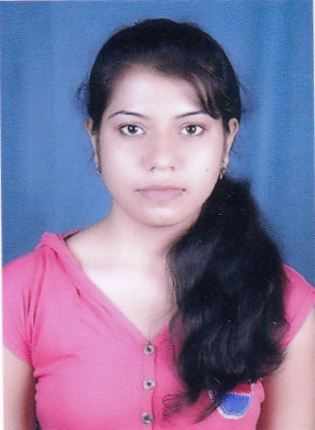
KOMAL MISHRA

Email Id- komalmishra1605@gmail.com
Cont. No.- +918085592477

Address-
C/O Garima Girls Hostel,
101, New Hanuman Nagar,
Kalibadi, Raipur (C.G.)

CAREER OBJECTIVES

Seeking an Opportunity to work with a Reputed Firm, that utilizes my Educational Skills and Strengths effectively, and enables me to make a positive contribution towards the growth of the Company.

Past Experience- Having 1.5 Years of Experience as Financial Advisor.

Companies worked with- ICICI Prudential Life Insurance- January 2014 to November 2014
Bharti Axa Life Insurance- November 2014 Onwards.

Responsibilities Handled-

=> To Identify Financial Needs of Customers, Analyze them and provide them Personalized Solutions.
=> To manage the Team, and make them to work together.
=> To handle Customers’ Queries and provide them proper and satisfactory solutions.
=> To fulfill the Company’s Monthly targets, and work towards Profitability of the company.
=> To provide proper services to the Existing Clients of the company, as well as make new clients.
=> To build up a Healthy Relationship with the customers, and to increase the Brand Value of the Company in Market.

EDUCATINONAL QUALIFICATIONS:-

DEGREE | INSTITUTION/  BOARD | YEAR OF  PASSING | MARKS OBTAINED
MBA  (HR +Marketing) | CSVTU, Bhilai | 2014 | 71%
BBA | APS University | 2009-2012 | 75 %
12th | NIOS | 2009 | 60 %
10th | CBSE | 2006 | 64 %

PERSONAL INFORMATION

Name - Komal Mishra
Father’s Name - Pramod Kumar Mishra
Date of birth - 16th May 1991
Nationality - Indian
Marital Status - Single
Permanent address - LIG- 380, M.P. Housing Board Colony
Priyadarshni Nagar, Sidhi (M.P.) 486661
Personality - Smart, Confident, Communicative, Enthusiastic and Friendly.
Language known - English and Hindi.

ACHIEVEMENTS

- Won Gold Medal from ICICI Prudential for Best Performance in March-2014.
- Got Certificate of Excellence from ICICI Prudential for Exemplary Performace.
- Having 45 Days Internship Training with HINDALCO, as an HR Employee.
- Have been the Vice-President of College during Graduation.
- Actively Participation in Di-Impulsion, Event of Best Manager.
- Stood Runner up for the Best Personality of College, during Graduation.

KEY STRENGTH

- Good Communication Skill.
- Self-confidence and Trustworthy.
- Punctual, Hardworking, and Polite.
- Analytical and Decision- making ability.

EXTRA CURRICULUM

- Won the “Best Singer Award” at District level Competition.
- Declared as “Voice of DIMAT” during MBA.
- Won Prizes in Sports, i.e. Bad-Minton And Discuss-Throw at School level.
- Have Positive Contribution in Many Cultural Activities in School and College.
- Won Many district, Cluster and Regional Level Singing and Dancing Competetion.

DECLARTION

I hereby declare that all particulars furnished in this application are true, complete and correct to the best of my knowledge and belief.

PLACE:- Raipur (C.G.) KOMAL MISHRA

